SUPERSTORE PROFIT DECLINE INVESTIGATION AND ANALYSIS REPORT

Prepared by: Nasif Abbas— Data Analyst
Date: 01 July 2026
Location: Riyadh, Saudi Arabia

1. Executive Summary
Over the past several months, Superstore has experienced a steady decline in profit across the South, Central, and East regions. To understand the root causes, full Power BI and Tableau dashboards were developed for analyzing product performance, regional trends, discount behavior, and monthly sales/profit patterns.
The dashboard reveals that although total sales remain strong at 2.30M, profit has dropped to 286.40K, with 566.73K in revenue given away through discounts and 530.89K in recoverable profit. The decline is driven by loss-making sub-categories, aggressive discounting, and regional margin erosion. This report summarizes the insights and provides clear recommendations to restore profitability.

2. Detailed Analysis
2.1 Underperforming Categories & Sub-Categories
Key Question: Which categories or sub-categories are underperforming?
The “Profit by Sub-Category” visual shows clear profit disparities:
Top Performing Sub-Categories (Profit Values)
- Copiers: 55.62K
- Phones: 44.52K
- Accessories: 41.94K
- Paper: 34.05K
- Binders: 30.22K
These sub-categories are strong contributors to overall profit.
Underperforming / Loss-Making Sub-Categories
- Tables: –17.73K
- Bookcases: –3.47K
- Supplies: –1.19K
- Fasteners: 0.95K (barely profitable)
These items are directly responsible for profit decline, especially Tables, which is the single largest loss-making sub-category.
Interpretation
The decline is concentrated in a small group of products. This suggests:
- High cost structure
- Excessive discounting
- Weak demand
- Poor pricing strategy
These sub-categories require speedy review.

2.2 Sales & Profit Trends Over Time
Key Question: How have sales and profit trends changed over time?
The “Sales & Profit by Month” visual shows:
Sales Trend
- Sales peak around August and December, reaching close to 0.35M in some months.
- Sales remain stable throughout the year.
Profit Trend
- Profit fluctuates between 0K and 0.10M, significantly lower than sales.
- Several months show high sales but low profit, indicating margin erosion.
Interpretation
Profit is not rising proportionally with sales. This mismatch suggests:
- Increased discounting
- Higher operational costs
- Lower margins on certain products
This confirms that the decline is not due to low sales, but due to profit leakage.
2.3 Factors Contributing to the Decline
Key Question: What potential factors (discounts, sales volume, etc.) are contributing to the decline?
The “Sales by Discount and Profit” scatter plot reveals:
Key Observations
- High discounts correlate strongly with low profit.
- Several transactions with high discount levels fall into negative profit.
- Some high-sales transactions still generate low profit due to discounting.
Supporting Dashboard Values
- Revenue Given Away: 566.73K
- Recoverable Profit: 530.89K
- Critical Loss Orders: 22
These values confirm that discounting is a major contributor to the decline.
Interpretation
Discounting practices are eroding margins across multiple regions. This is one of the strongest drivers of the profit decline.

2.4 Regional Comparison
Key Question: Which region had the major decline?
The dashboard shows:
Sales by Region
- West: 31.58%
- Central: 29.55%
- East: 21.82%
- South: 17.05%
Profit by Region
- West is the strongest profit contributor, closely followed by the East.
- South and Central show significantly lower profit.
Interpretation
The South Region has the most severe decline, followed by Central. Sales are not the issue — profit margins are.

3. Conclusion
The profit decline is driven by three main factors:
1. Loss-making sub-categories
Tables (–17.73K), Bookcases (–3.47K), Supplies (–1.19K), and Fasteners (0.95K) are dragging down overall profit.
2. Seemingly Aggressive discounting
With 566.73K in revenue given away, discounting is eroding margins across multiple regions.
3. Regional margin erosion
South, Central, and East regions show declining profit despite stable sales.
Overall, the decline is not caused by low sales, but by poor margin control, unprofitable products, and regional discount practices.
4. Recoverable profit
The potential 530.89K in recoverable profit shows that a large portion of the decline can be reversed through better margin control.”

4. Recommendations
4.1 Adjust Pricing & Discount Strategy
- Reduce discounts on loss-making products.
- Introduce minimum margin thresholds.
- Implement region-specific discount controls.
4.2 Reassess Underperforming Products
- Conduct cost analysis on Tables, Bookcases, Supplies, and Fasteners.
- Consider discontinuing or redesigning these products.
- Explore alternative suppliers.
4.3 Strengthen Regional Oversight
- South Region needs immediate intervention.
- Train managers on pricing discipline.
- Introduce margin-tracking dashboards.
4.4 Optimize Inventory & Operations
- Reduce stock of loss-making items.
- Increase focus on high-profit products.
- Improve forecasting.
4.5 Set sights on Target
- Target the recoverable profit by tightening discount rules, improving deal approval, and reducing margin-eroding transactions.”
4.6 Continue Monitoring
- Track monthly profit vs sales.
- Add alerts for negative-margin transactions.
- Use Power BI and/or Tableau dashboards for ongoing decision-making.

5. Final Statement
This analysis provides a clear, data-driven understanding of the profit decline across key regions. By addressing discounting practices, optimizing product strategy, and strengthening regional oversight, Superstore can reverse the decline and improve profitability.

POWERBI DASHBOARD

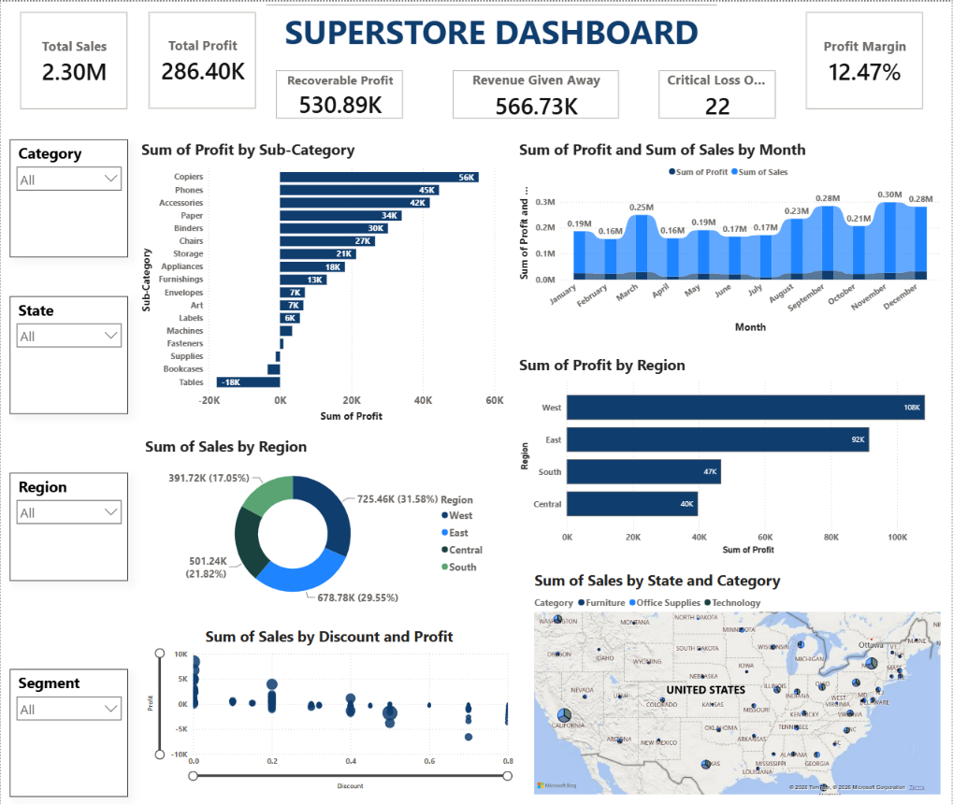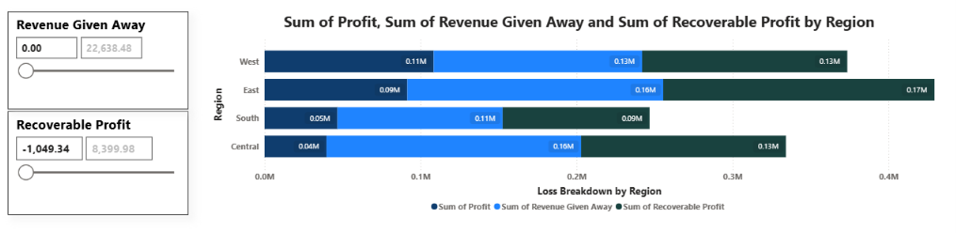

TABLEAU DASHBOARD

